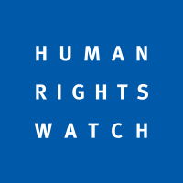
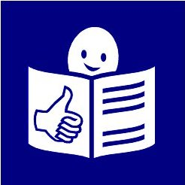

HIV and disability

Who we are

We are called Human Rights Watch.

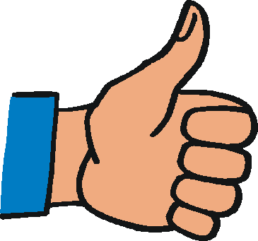
We work to make sure that people around the world have their rights and are treated in the right way.

What this document is about
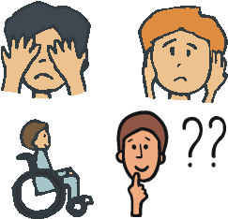

This document is about people with disabilities
and HIV.

What is HIV?

HIV is a disease.

It is something that happens to your body.

It makes it harder for your body to fight illnesses.

People with HIV may get AIDS later on.

AIDS is where someone’s body is very weak and cannot fight illnesses.

People can get HIV by doing things like

- having sex without a condom

- taking drugs using a needle and sharing the needle with other people.

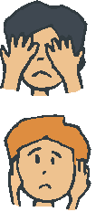
People with disabilities and HIV

People with disabilities can get HIV just like everyone else.

They may be more at risk of HIV than other people.

This is because people with disabilities
- can find it hard to get the help they need

- are often treated badly.

Much more needs to be done to
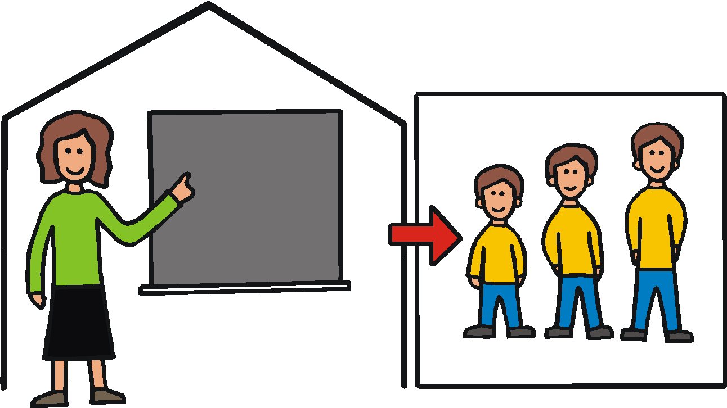
- stop people with disabilities getting HIV

- help people with disabilities who get HIV.

Problems for people with disabilities

1. Not getting the right information or care

People with disabilities are often treated badly because of their disability.

Other people may not understand about
people with disabilities.

For example, people may think that
people with disabilities

- do not have sex or cannot have children
- cannot learn things.

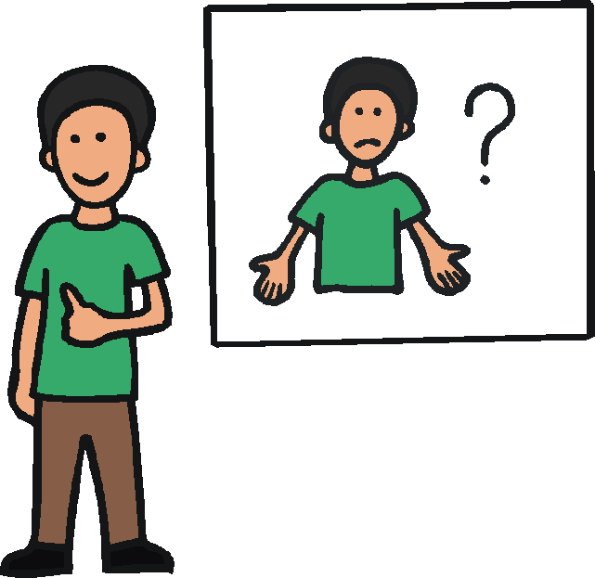

This means people with disabilities often do not get the support they need.

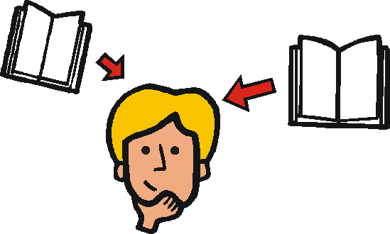
People with disabilities find it harder to get
things like

- information about safe sex
- condoms to have safe sex with.

This is because some people with disabilities find it hard to get to health centers or hospitals.

People with disabilities can also find it very hard because of things like

- information that is hard to understand
- health centers that are hard to get to
- medicine that costs a lot of money.
2. Being treated badly by other people and not getting the right help

People with disabilities can be more at risk of being treated badly.

For example, some people may

- be violent to people with disabilities
- make them do sexual things they do not want to do.

People with disabilities can also find it harder
to get help if they are treated badly.

For example they may find it hard to get

- help to make sure they do not get HIV
- help from the Police or the law.

What we found

In 2010 we looked at what was happening in a country called Uganda.

We found many women with disabilities had been forced to have sex or been hurt by someone else.

Some women who were forced to have sex found it very hard to get

- a test to see if they had HIV
- the right care and support.

What we think should happen

We think everyone should work together to make sure people with disabilities get the right support.

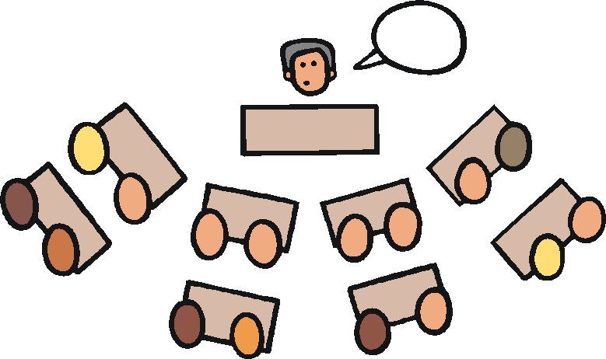

We think people like governments and HIV groups should do these things

- Work with people with disabilities to find out what they need.

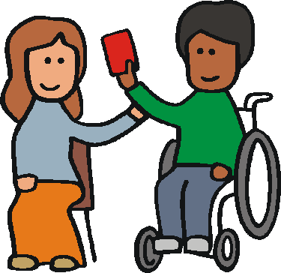

- Make sure it is easy for all people with disabilities to get good care and support for HIV.

- Give people information about HIV and
safe sex that is easy to understand.

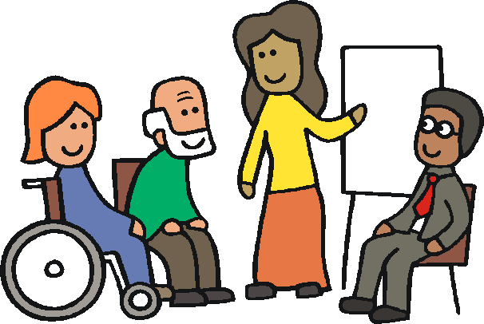
- Make sure staff and people with disabilities have good information and skills.

- Find out more information about
people with disabilities and HIV.

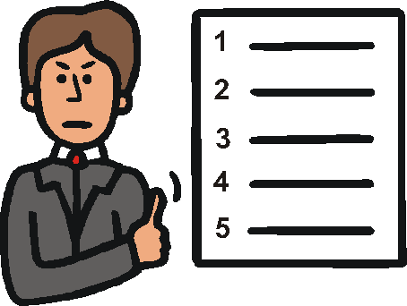

- Make sure governments have good laws to keep people with disabilities safe.

- Help to make sure that people with disabilities
- can have safe sex,
- have their rights
- are treated in the right way.

Some stories about people with disabilities and HIV

Help for people with intellectual disabilities with HIV in Kenya

There is a group helping people with intellectual disabilities
in Kenya who have HIV.

In Kenya people with intellectual disabilities are often
shut at home away from other people.

So the group is making sure people with intellectual disabilities get good information.

For example, they are making a radio programme
for people to listen to.

The radio programme tells people with HIV about
some medicines they can get.

A story about John Meletse

John Meletse lives in South Africa.

John has HIV.

He is also deaf.

John was told he had HIV in 2001.

Health staff could not talk to him using sign language.
So they showed him a piece of paper that said he had HIV.

Then he was told to go away.

John was very upset.

He did not understand what was happening.

He did not get the right help.

Then John decided to do something good to
help other deaf people.

He now works hard to make sure
people with disabilities get the right support with HIV
and are listened to.

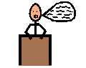

Easy words by Mencap.

